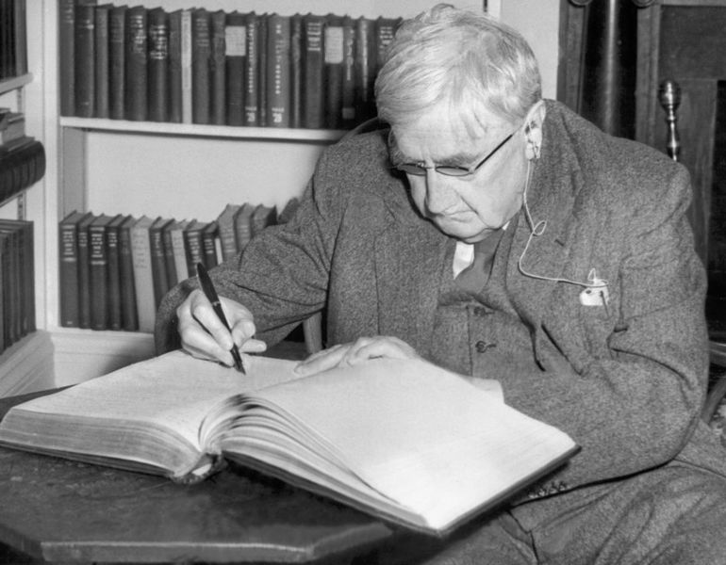

Context:

* Ralph Vaughan Williams, 1872-1958
* On Wenlock Edge, written 1909.
* Vaughan Williams was born in Gloucestershire, and received education at Charterhouse, the Royal College of Music and Trinity College, Cambridge.
* Like many other early 20th century composers, Vaughan Williams sought to break away from the German Romantic tradition that had dominated in the previous century.
* He was also part of the English Musical Renaissance of the late 19th to early 20th century where English composers (Hubert Parry and Charles Villiers Stanford were early pioneers of the movement), sought to break away from the influence of the continent and create their own national idiom.
* This Renaissance included revisiting earlier English music - Tudor music of Tallis and Byrd - and folk music, as well as taking inspiration from the English bucolic background.
* Vaughan Williams dedicated decades of his life to collecting folk songs; the influence of this music is very apparent in his music, especially in its modal nature.
* On Wenlock Edge is a song cycle written comparatively early in VW’s career. It is a collection of six songs which set the text of E A Housman’s *A Shropshire Lad* which was written in 1896. Butterworth also set these songs, making for an interesting comparison with Vaughan Williams’ own.

**On Wenlock Edge, Vaughan Williams**

**Wider listening**

Composers for comparison:

Butterworth

Finzi

Holst

Howells

Tippett

Delius

Elgar

Britten

Mahler

Schubert

* Vaughan Williams studied in Paris with Ravel for a short period before writing this cycle; the impressionist influence can be heard in the music as will be discussed later.

Melody

Wider listening by element

|  |  |
| --- | --- |
| Tippett Concerto for double string orchestra | * Folk influences in the melodic style of some of themes, e.g. mvts 2 and 3 (as in most of VW’s writing in the cycle). |
| Vaughan Williams Linden Lea | * An original composition but it sounds like a folk song: simple repetitive phrases with conjunct movement. In *On Wenlock Edge (OWE)*, the melodies are more complex and include more awkward intervals such as several tritones. |
| Vaughan Williams Five Variants of Dives and Lazarus | * One of the few occasions where Vaughan Williams directly quotes a folk song in his music. * In this work, the song Dives and Lazarus is heard five times in different “variants”. |

Structure/form

|  |  |
| --- | --- |
| Schubert Die schöne Müllerin, Die Winterreise and Erlkönig | * These are three examples of German Romantic art song, Lieder, by Schubert. * The structure of these song cycles depends on the text: * Strophic if conveying same idea throughout as in *Das Wandern* from *Die schöne Müllerin*. * Modified strophic - repeats for some verses but not for others - if there are several ideas being conveyed e.g. *Der Lindenbaum* from *Die Winterreise*. * Through-composed for longer narratives e.g. the ballad Erlkönig. * In OWE, we have more a modified strophic pattern dominating - while some verses are almost exactly repeated, others are either variated or completely different. |
| Vaughan Williams Linden Lea | * Strophic - exactly the same melody in all three verses. * A simpler, shorter composition than the song cycle. |
| Finzi Let us Garlands Bring | * Another English song cycle, written between 1929 and 1942. * It consists of five songs set to songs from Shakespeare’s plays, maintaining the emphasis on English heritage and patriotism. |

Harmony/tonality

|  |  |
| --- | --- |
| Debussy La Cathedrale Engloutie | * Modal harmony * Parallel chords * Pentatonicism * All three are features of Debussy’s Impressionist style that also occur in OWE. |
| Tippett Concerto for Double String Orchestra | * Is tonally ambiguous: uses modes e.g. Lydian, and pentatonicism. The piece is influenced by Tudor music which was often modal. * Uses non-functional harmony. False relations resemble music of the English Renaissance that use the mixolydian mode. (That is *the* Renaissance, not to be confused with the English Musical Renaissance of the 19th to 20th centuries!) |
| Vaughan Williams Five Tudor Portraits and Fantasia on a Theme of Thomas Tallis | * VW wrote several works based explicitly on Tudor music. * Fantasia on a Theme of Thomas Tallis uses the phrygian mode and is static harmonically, regularly returning to the “tonic” G minor in the first section. |

Texture

|  |  |
| --- | --- |
| Finzi Let Us Garlands Bring | * Written for solo tenor and piano with an alternative string quartet accompaniment. More conventional than the piano quintet in OWE. * A much thinner texture is created with the more common piano version. |
| Butterworth Bredon Hill | * Bredon Hill, no.1 of the cycle by the same name, has piano chords in the opening like bells, repeated as an echo. * Fast piano chord figurations later on in the song also represent bells. Quite a busy texture under the voice. * This comment is also applicable to word painting and setting the atmosphere. |
| Debussy La Cathedral Engloutie | * Parallel chords and held low notes dominate the texture. |

Sonority/Dynamics

|  |  |
| --- | --- |
| Debussy La Cathedral Engloutie | * Bell effects as in *Bredon Hill* of OWE. |
| Mahler Kindertotenlieder | * Replaces piano accompaniment for the song cycle with full orchestral accompaniment. The next step from VW’s enlarged ensemble. |
| Butterworth Bredon Hill | * The bell like chords in the opening * Faster figurations later on * (see texture) |
| Finzi Let Us Garlands Bring | * Uses string quartet OR piano, not both. |
| Vaughan Williams Charterhouse Suite | * VW scarcely wrote for piano - his Charterhouse Suite is an example of music for solo piano, but it is not conventionally pianistic writing. * He was much more accustomed to writing for strings. |

Tempo/metre/rhythm

|  |  |
| --- | --- |
| Tippett Concerto for Double String Orchestra | * The concerto was influenced by secular 16th and early 17th century music (madrigals and fantasias) which are flexible in metre, and therefore so is Tippett’s music. * All three songs in OWE have a change in time signature at some point. |
| Vaughan Williams Jolly Rutterkin | * Ambiguous/changing metre. |