Name:

Form:

Teacher:

**The**

**A Level Mindset**

V - Having a **Vision**

E - Commitment to the **Effort**

S - Having **Systems**

P - **Practice**

A - Positive Mental **Attitude**

**The A Level Mindset**

**WHAT IS VESPA?**

|  |  |
| --- | --- |
|  | * **Do you know what you want to achieve?** * **Why are you studying A Levels?** * **What grades do you want to achieve in your A Levels?** * **What career are you interested in?** |
|  | * **How many hours of independent study do you do?** * **How do you compare to the most committed students in your year group?** |
|  | * **How do you organise your learning and your time?** * **Do you have any study or time management methods or techniques to draw on?** |
|  | * **How do you practice to improve your study skills?** * **How do you practice to improve your time management?** |
|  | * **How do you respond to setbacks?** * **How do you respond to constructive criticism?** * **How do you overcome setbacks or adapt your**   **plans?** |

**VISION**

**20 QUESTIONS**

1. If you had the afternoon off to work from home, what piece of work would you do?
2. When you have a lot of homework which subject do you do first?
3. Describe a homework task you have left to the last minute or not done at all. Why?
4. What do you get obsessed about?
5. When you are with friends what do you want to talk about?
6. What stresses you out?
7. If you had a free hour, what would you type into google search?
8. If you were given money to start a company, what would it be?
9. List 5 words you associate with happiness.
10. If you could only take one subject, what would it be and why?
11. What lessons or elements of study do you find easy?
12. What do you with your spare time?
13. Describe an interesting lesson you had recently. Why was it interesting?
14. What tasks do you avoid doing? Why?
15. When does time fly? What

activities are you doing?

1. When does time seem to drag? What are you doing?
2. What job would you do for free?
3. Who do you look up to?
4. What would you try if you

knew you wouldn’t fail?

1. What puts a smile on your face?

DREAM – something you imagine happening

**VISION DREAMS V GOALS**

GOAL – something you take actions towards; you are doing something to turn it from an idea into a reality.

There is nothing wrong with having dreams, they are inspirational. However, if you take no action towards turning them into reality they are just make believe. It is also important to acknowledge any step, no matter how small, towards your goal.

|  |  |
| --- | --- |
| **Pure Fantasy**  Things you would one day like to be but have never spoken to anyone about them, they are just in your head. |  |
| **Daydreams and Conversations**  These are things you would like to do that you have started to explore or to talk about with others. |  |
| **Goals**  They are things you would like to do that you have started taking action towards. What was the action? When did you last take action? |  |

Complete the table above and then reflect on the questions below:

1. What % of your hopes have you acted on? What chance is there of these hopes becoming a reality?
2. How much action have you taken? Has it been repeated, determined action or has it been just one action taken a long time ago?
3. What further actions do you need to take to turn those dreams into goals? What help do you need with doing that?

It’s your 21st birthday. Your friends and family stand up one by one to speak about you. What do you want them to say?

**Your best qualities are**

**…**

**They admire you because**

**…**

**Your best achievements so far are …**

**Your hopes and ambitions are…**

By creating a vision of what you would like people to say about you it gives you an indication of what you value most about yourself and what you would like your life to be. This can be useful when making next steps. What do you need to do in the near future to ensure these things will be said about you at your 21st birthday?

What about further into the future? What will they say about you at the age of 60?



**EFFORT**

**ABILITY OR COMMITMENT?**

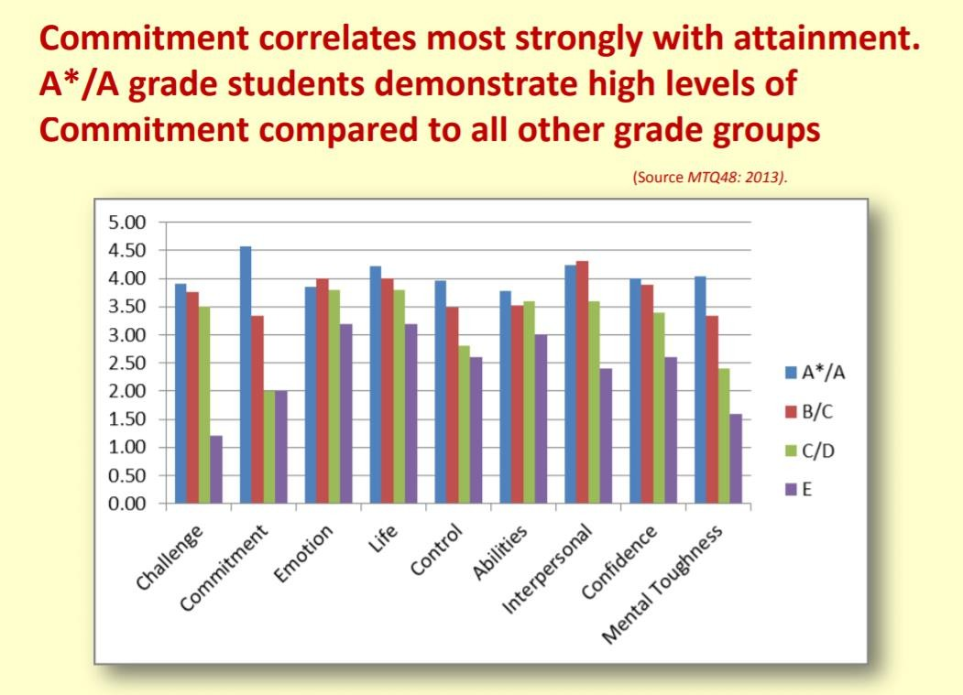

You will often here students say ‘They got better grades because they are smarter than me.’ But looking at the information above that is often not the truth.

Look at ‘Abilities’. There is minimal differences in abilities brought

into A Levels from GCSE by those who achieved grades 9-4.

Now look at ‘Commitment’. There is a vast difference between the amount of commitment, or effort, displayed by those getting the highest and lowest grades.

IT IS NOT WHAT YOU BRING WITH YOU INTO THE SIXTH FORM THAT

COUNTS, IT IS WHAT YOU DO WHILE YOU’RE HERE THAT MATTERS!



**EFFORT**

**ON A SCALE OF 1-10**

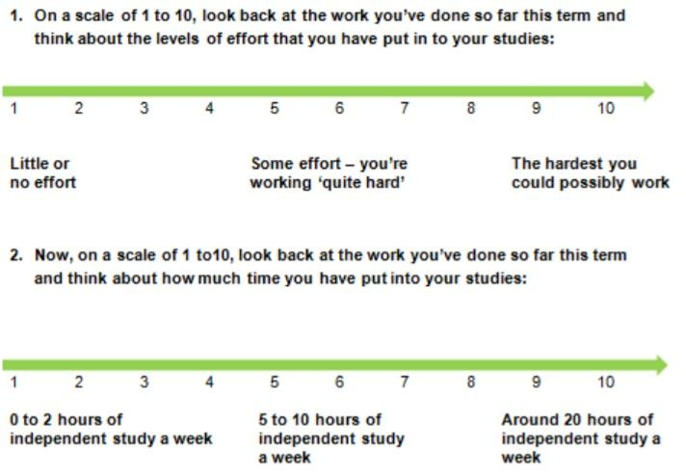

REFLECTION:

* Look at your two numbers. Is your perception of how hard you are working matching the reality?
* The number of hours on the bottom scale come from research into working habits of thousands of A Level students. The study found that those who achieved 3 A grades or higher spent approx. 15-20 hours outside of their allotted classroom time studying.
* What can you do? Do you plan your independent study? Have you downloaded past papers? Have you started to create revision resources? Are you regularly revisiting your notes to recap your knowledge? Are you making the most of your private study time when in school and at home?

A ‘blocker’ is a barrier that stops you working. We all have them. To

put in effort for A Level success you must recognise your blockers.



**EFFORT RECOGNISING YOUR BLOCKERS**

|  |  |  |
| --- | --- | --- |
| Blocker | How it impacts you | What you can do about it |
| I don’t enjoy the task |  |  |
| I’m not convinced I need to do it |  |  |
| I can’t concentrate |  |  |
| I don’t know where to start |  |  |
| My friends haven’t done it either |  |  |
| I like socialising too much |  |  |
| The instructions weren’t clear |  |  |
| I needed a break |  |  |
| Other people distract me |  |  |
| My phone keeps ringing |  |  |
| I won’t need this for my career |  |  |
| I didn’t hand it in last time and no  one cared/ told me off |  |  |
| I will do the next one |  |  |
| My exams aren’t until next year |  |  |

Each of the blockers above can be categorised into:

* Initial lack of motivation
* Bypassing conscience – creating excuses to make fool ourselves into thinking its ok.
* Creating an opportunity – finding a reason not to do something or something to blame for not doing it.
* Getting away with it – no one killed you for not doing it before so let’s repeat it.

Task 1 - In column 2 rank order from 1 -14 how these apply to you

Task 2 - In column 3 put in a practical solution your top 5 blockers.

Reflection – What are the main blockers to your success and what can you do to ensure you don’t sabotage your success?

You have identified your blockers and are aware of what you have to do. But doing it can be somewhat difficult. How many of the following can you say are true of you?

* + It’s too hard, I will leave it to later (and rarely go back to it)
  + I have other things to do that ‘might’ be more important
  + Instead of tackling the daunting and difficult essay, go and read one or more other texts, rewrite notes, read through your plan etc. tricking yourself that you are now closer to finishing the essay than you were previously.
  + Talk to lots of people about the work instead of actually doing the work.

We all do it. If we have a to do list we all head to the easy, quick win tasks and tick them off following ourselves into thinking our list is nearly complete. Sometimes the thought of doing the work is actually worse that the work itself.

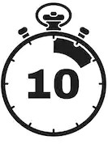

The 10 minute rule

1. Tell yourself you are going to do just 10 minutes of intense work.
2. Decide what task to get started (particularly focus on the one you have been putting off as it is too hard or too big.
3. Clear a space and sit down with the right materials to hand.
4. Start
5. If you stop after the 10 minutes are up at least you have started the task. Often what happens is that 10 minutes becomes 20 etc.

Studies show that students who regularly review their learning, identifying areas of strength, areas to work on and know their deadlines and next steps to get there, are more likely to be successful AND LESS STRESSED!

**EACH WEEK YOU SHOULD DEDICATE ONE HOUR OF PRIVATE STUDY (PREFERABLY ON A FRIDAY) TO COMPLETING THIS TASK.**

There are 2 parts to the task

* Part A – A record of the private study that you have completed inside and outside of school this week. This should take no more than 20 minutes to complete, less if you simply update daily as you go through the week. This is used to look at your effort levels and to identify if you are spending too much time on one subject to the detriment of the others. Remember, a typical student who goes on to achieve 3 As (or higher) spends at least 15-20 hours a week in private study.
* Part B – A reflection on your progress. There is a box for each subject and a 4th box which can be used for anything else e.g. careers research, EPQ, enrichment. Spending 10 minutes on each box reflect on the set of questions, recording your ideas. Completing this should mean that you can leave for the weekend fully aware of what you are going to tackle the following week. You should create a to do list as you work through each box.

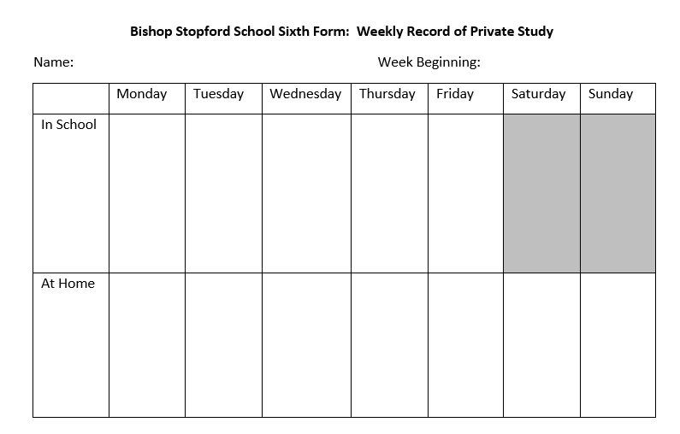

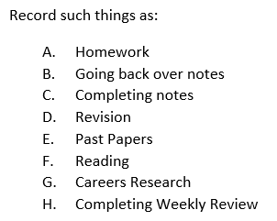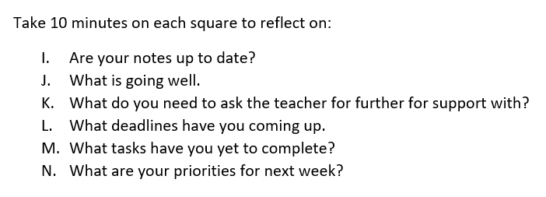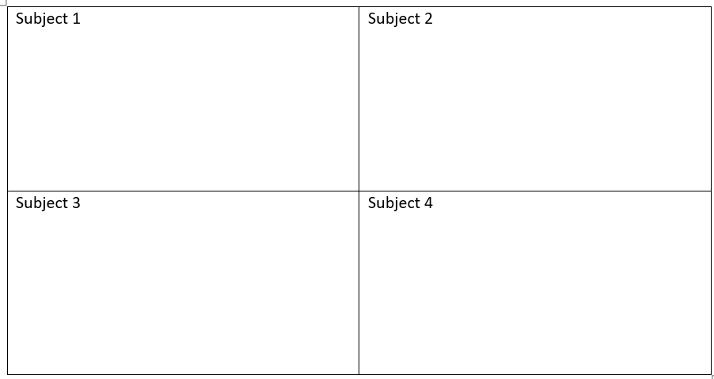

Former American President Dwight Eisenhower was considered a master of time management, always getting everything done by the deadline.

His famous quote was ‘I have two kinds of problems, the urgent and the important. The urgent are not important and the important are never urgent.’

This Eisenhower Matrix sets out his philosophy.

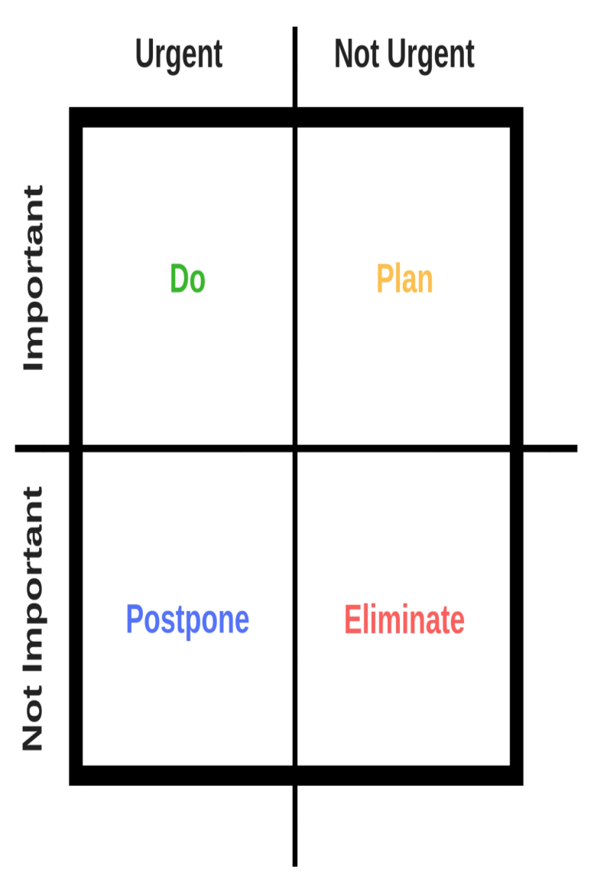

Write down your tasks and then place them into one of the four boxes.

Then tackle the boxes in this order:

* + Urgent and important – these are must do nows!
  + Not urgent but important. These may move into box one with time so plan these next.
  + Urgent but not important - these can be put off until later.
  + Not urgent and not important – question if it needs to be done at all?

Cue cards are a great way to memorise the important facts and figures for your exams. They help to improve your memory. Follow the instructions below to make the best use of your cards:

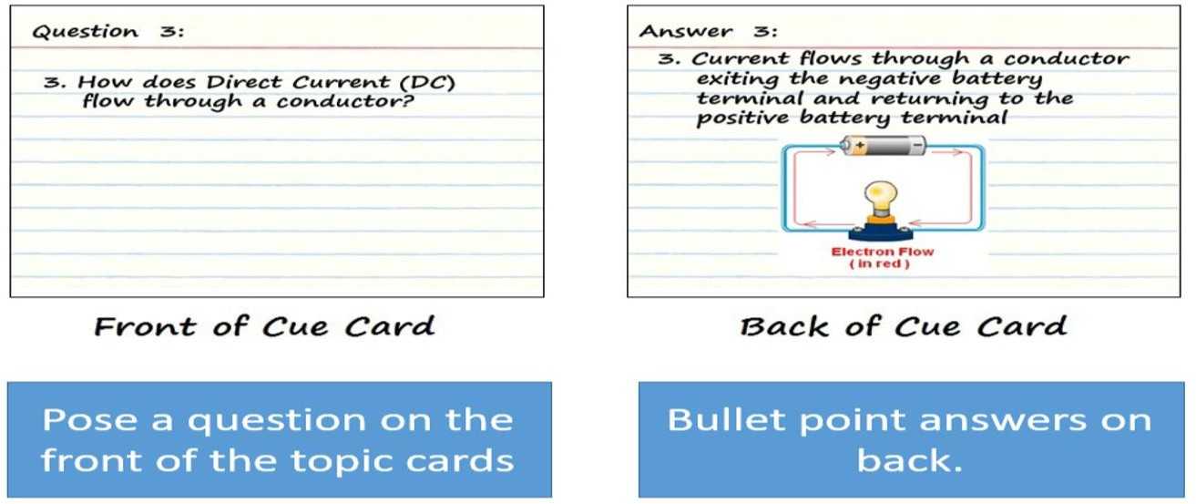

TIPS

* Number your cards
* Different coloured cards for different topics
* Find a way to store e.g. boxes, keyring loops, wallets

**Getting started with cue cards**

* **Pick a topic**
* **Read through your notes on that topic**
* **Break down the notes into key parts**
* **Turn those key parts into questions, these go on the front of your cards, then answer on the back**
* **Check back through your notes to make sure you have covered the major themes.**

Cue cards are not useful just because you spend time making them. You actually have to use them to ensure the information becomes stored in the long term memory.

**Every day**

**Tuesday and Thursday**

**Friday**

## Have 3 boxes/ folders/ sections in folder

* Label them Every Day, Tuesday and Thursday, Friday
* All cards start in the everyday box
* Monday – if you answer the card correctly it goes into the Tuesday and Thursday box. If incorrect it stays in the every day box
* Tuesday do the everyday box first. Same as above if right goes into the Tuesday and Thursday box, if wrong stays in every day box. Then do the Tuesday and Thursday box. If correct card goes into Friday box. If wrong goes back into every day box.
* Repeat daily.
* You can refresh cards, or change topics as you like.

When doing A Levels you will sit exams of some description. Revision is therefore, extremely important. The type of revision you do is also important.

STEP 1 - complete the revision questionnaire

|  |  |  |  |  |
| --- | --- | --- | --- | --- |
|  | Phase | Always | Sometimes | Never |
| Preparing a revision wall to display your learning | C |  |  |  |
| Creating flash cards to cover content | C |  |  |  |
| Highlighting / colour coding notes | C |  |  |  |
| Remaking class notes | C |  |  |  |
| Making mind maps, diagrams or graphic organisers | C |  |  |  |
| Reading through class notes | C |  |  |  |
| Reading through course text books | C |  |  |  |
| Watching online videos | C |  |  |  |
| Writing exam answers under timed conditions | S |  |  |  |
| Planning responses to past questions | S |  |  |  |
| Reading through model answers | S |  |  |  |
| Comparing model answers with your own | F |  |  |  |
| Creating your own exam questions | F |  |  |  |
| Handing in extra work for marking | F |  |  |  |
| Marking your own work to a mark scheme | F |  |  |  |
| Studying mark schemes and examiner reports | F |  |  |  |
| One-to-one discussions with teacher/tutor | F |  |  |  |
| Working with other pupils to compare answers | F |  |  |  |

Researchers have found a strong correlation between the type and variety of revision students carry out and their success in final exams. Underperforming students select for themselves a limited set of revision tasks based around repetition of lower challenge activities. To be truly successful learners you need to work through all three phases of practice throughout the year.

CONTENT- If you just constantly focus on memorising information you often get frustrated when you put that info down in the practice exams and don’t get the high marks because you haven’t mastered the skills you need to answer the questions. Often these are students who spend hours creating beautiful cue cards, highlighting in a range of colours and plastering walls with mind maps.

CONTENT AND SKILLS - These pupils know they need to do more than just know material. There know that they have to become familiar with the exam paper structure and complete large numbers of papers. BUT they never mark them because they are worried that their scores won’t be good enough and their hard work will be wasted.

CONTENT AND FEEDBACK - These pupils see the feedback stage as another process of memorisation. They will memorise mark schemes and the formulae to answer questions without attempting to answer themselves. Because they have missed the skills step their knowledge is theoretical so end up having a meltdown if the questions are worded slightly differently on exam papers .

**CONTENT AND SKILLS AND FEEDBACK - These pupils know they need to learn and be able to recall the material. They know that they have to become familiar with the exam paper structure and complete large numbers of papers. They mark these papers using the mark scheme and look at the examiners reports. They seek feedback at all stage. Because they have worked on the skills step they can cope well if the questions are worded slightly differently on exam papers.**

Most of your independent study time is in units of one hour in length. It is important that you make the most of these hours. As we approach exams, more time should be spent on revision, although I would highly recommend **that revision is something that is ongoing throughout the course**. THE POWER HOUR is a good way to use a private study lesson.

Step 1 – find past paper questions (a good tip is to spend some time collating a long list of past paper questions and mark schemes for all of your subjects).

Step 2 – USE A TIMER – give yourself 20 minutes to revise through your notes on anything you will need to answer the question you have chosen.

Step 3 – USE A TIMER – give yourself 20 minutes to answer the question you have set

Step 4 - USE A MARK SCHEME –

Compare your response to the comments made on the examiner mark scheme. If you have missed anything out or gotten anything incorrect make additions in a different coloured pen. It will help you when you look back over these questions and answers at a later date.

Step 5 – GET FEEDBACK – this can from yourself based on how well you have done based on the mark scheme. It can be from another student if you are working in a revision group or if you have struggled speak to your teacher.

Research Study:

Aim – to throw a scrunched up piece of paper into a bin from 3 yards

* Group A – practiced 100s of throws from exactly 3 yards
* Group B – practiced hundreds of throws alternating between 2 and 4 yards
* When tested Group B performed better because
  + They were flexible in their approach. Some practice was easier than the final task, and some was much harder. They weren’t phased by the final task.
  + Group A were rigid/mechanical in their approach. They repeated the same thing time and time again.

By being flexible and preparing for the most difficult/ weird questions you should come out of any exam

saying ‘The question was slightly different but eventually I figured out what I needed to do.’

HOW DOES THIS APPLY TO YOUR STUDY?

* When looking at past papers and examiner reports try to find the hardest/ weirdest questions that have been asked.
* Create your own strange ways to ask the question
* Visit the website of a different exam board and look at their questions for the same content.

Have you ever come out of an exam stressing about a particular question? You kind of know what the question was about but because it was asked in a way that was slightly different to what you practiced it threw you off your game. This is because you have not been flexible when preparing for assessments.



**ATTITUDE**

**STOPPING NEGATIVE THOUGHTS**

Attitude is a term used to describe:

* Outlook on learning and how it happens
* How a person responds to setbacks or levels of challenge
* How well a person is able to keep going and not give up

Have you ever said any of the following?

* I’m too disorganised
* I’m too far behind now
* Life isn’t fair
* I’m not clever enough
* Everyone else gets it but me.

I’m dumb.

* No one explains things properly. I don’t stand a chance.

Think really hard. Are you …

* Blaming yourself for something you cannot control?
* Secretly willing yourself to fail so you don’t have to try so hard?
* Making excuses to avoid having to work hard?
* Blowing things out of proportion and not seeing the real picture?

In his book, How to stubbornly refuse to make yourself miserable,

Albert Ellis shows how stressed students often had ‘crooked thinking’. He argued that, you have to first realise that you are having negative thoughts and then you have to reframe them into something positive

|  |  |  |
| --- | --- | --- |
| Type of thinking | Example | Reframe it |
| Not fair thinking | I don’t deserve this treatment. Things shouldn’t be like this. | I did what I could. It’s a setback but I can handle it. |
| Catastrophe thinking | If this goes wrong, it’ll be a total nightmare. | I’m going to perform well. I prepared thoroughly. |



**ATTITUDE**

**STOPPING NEGATIVE THOUGHTS**

|  |  |  |
| --- | --- | --- |
| Type of thinking | Example | Reframe it |
| Stopper thinking | I’m useless. I can’t do this. I’m bound to screw up. | I’m learning, I’m getting better each time. I will get there. |
| Illogical thinking | If this bad thing happens, then this other bad thing will follow. | There’s no direct connection between this and that. The past does not equal the future. Tomorrow is another day. |
| Blaming thinking | It’s the teacher’s  fault. It is anyone  else’s fault but mine. | It doesn’t matter whose fault it is. The important thing is that I learn from it and do something about it. |
| Overgeneralising | I never get a break. This always happens to me. Everyone else has it so much easier. My life is a disaster. | There are a few problems I am dealing with at the moment. Everyone has their own problems, I am going to get through mine. |

Have a go at trying to reframe some of the thoughts below:

* + I’ve never been good at

exams.

* + If my report is bad my parents are going to hate me.
  + The teacher doesn’t like me

as much as the others.

* + I’m not going to get the grades to get into university so the rest of my life is going to be miserable.
  + Stuff like this always happens to me.
  + I’m going to fail so what is

the point in trying?

* + I’ve been rubbish at math’s since primary school, I’m not going to get any better now.
  + Nothing in my life is typical or straightforward. Why is it always me?

When you get feedback on your work, which of the following best describes your outlook?

|  |  |
| --- | --- |
| I’m not good at  this | What am I missing? |
| I give up! | I’ll use some of the strategies I’ve learned |
| This is too hard | This may take some time and effort |
| I can’t make this  any better | I can always improve I’ll keep going |
| I’ll never be as  smart as her/him | I’m going to figure out what s/he does and try it |
| It’s good enough | Is this really my best work? |

People who become brilliant at something have failed many times but, importantly, they have learned from each of their mistakes. Are you going to let failure draw you backwards or learn from it and let it push

you forward?

|  |  |
| --- | --- |
| **Falling backwards** | **Falling forwards** |
| Blaming others | Talking responsibility |
| Making same mistakes | Learning from each mistake |
| Expecting to never fail | Knowing that failure is part of the process |
| Being limited by past mistakes | Taking new risks |
| Thinking ‘I’m a failure.’ | Believing something  didn’t work |
| Withdrawing effort | Persevering |

**TASK:**

* + - **Take a recent failure, upset, or score not as good as you wanted.**
    - **Look at the feedback. What are the suggestions for improvement? Rephrase in own words.**
    - **List what you are going to do differently next time.**