**A level Physics**

**OCR specification A**

**Year 11 to 12**

**Transition booklet**

**Name: .**

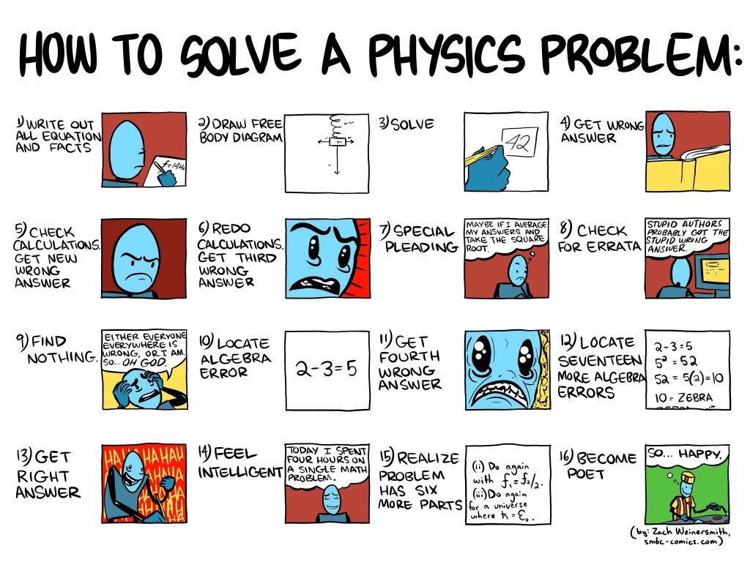

**Contents**

**Chapter Topic**

1 Physical Quantities/Units

2 Standard Form

3 Converting Units to SI Units

4 Prefixes/Converting Unit Magnitudes

5 Re-arranging Equations

6 Using Your Calculator

7 Significant Figures

8 Solving Numerical Problems

9 General Information

**If you require any additional help please email** [**pmann@bishopstopford.com**](mailto:pmann@bishopstopford.com) **or** [**jhollins@bishopstopford.com**](mailto:jhollins@bishopstopford.com)

**Chapter 1:**

**Physical Quantities/Units**

When we first look at numerical problem in Physics we need to be able to recognise what quantities we are given in the question. This can be made a lot easier if we know what quantity corresponds to the units given in the question. For example, if a question says someone’s speed changes at a rate of

5 ms-2, you need to be able to recognise that ms-2 is the unit of acceleration and so we know that we

have been given an acceleration (even though the word acceleration wasn’t used in the question).

We can classify physical quantities as either

(a) Basic: These are **fundamental** which are **defined** as being independent

There are seven basic quantities defined by the Systeme International d’Unites (SI Units). They have been defined for convenience not through necessity (force could have been chosen instead of mass, for instance). Once defined we can make measurements using the

correct unit and measure with direct comparison to that unit.

|  |  |  |
| --- | --- | --- |
| **Basic quantity** | **Unit** | |
| **Name** | **Symbol** |
| Mass | Kilogram | kg |
| Length | Metre | m |
| Time | Second | s |
| Electric current | Ampere | A |
| Temperature | Kelvin | K |
| Amount of a substance | Mole | mol |
| Luminous intensity | Candela | cd |

NOTE: Base units are also referred to as dimensions. You do not need to learn this table, it is included for information only.

(b) Derived: These are obtained by multiplication or division of the basic units  **without** numerical factors. For example:

|  |  |  |
| --- | --- | --- |
| **Derived quantity** | **Unit** | |
| **Name** | **Symbols used** |
| Volume | Cubic metre | m3 |
| Velocity | Metre per second | ms-1 |
| Density | Kilogram per cubic metre | kgm-3 |

Some derived SI units are complicated and are given a simpler name with a unit defined in terms of the base units.

**Farad** (F) is given as m-2kg-1s4A2 **Watt** (W) is given as m2kgs-3

A table of quantities with their units is below along with the most commonly used symbols for both the quantities and units. ***Note that in GCSE we wrote units like metres per second in the format of m/s but in A-level it is written as ms-1***

|  |  |  |  |  |  |  |  |
| --- | --- | --- | --- | --- | --- | --- | --- |
| **Quantity** |  | **Quantity** |  | **SI Unit** |  | **Unit Symbol** |  |
| Length | | L or l | | Metre | | m | |
| Distance | | s | | Metre | | m | |
| Height | | h | | Metre | | m | |
| Thickness (of a Wire) | | d | | Metre | | m | |
| Wavelength | | λ | | Metre | | m | |
| Mass | | m or M | | kilogram | | kg | |
| Time | | t | | second | | s | |
| Period | | T | | second | | s | |
| Temperature | | T | | Kelvin | | K | |
| Current | | I | | Ampere | | A | |
| Potential Difference | | V | | Volt | | V | |
| Area | | A | | Metres squared | | m2 | |
| Volume | | V | | Metres cubed | | m3 | |
| Density | | ρ | | Kilograms per metre cubed | | kg m-3 | |
| Force | | F | | Newton | | N | |
| Initial Velocity | | u | | Metres per second | | ms-1 | |
| Final Velocity | | v | | Metres per second | | ms-1 | |
| Energy | | E | | Joule | | J | |
| Kinetic Energy | | EK | | Joule | | J | |
| Work Done | | W | | Joule | | J | |
| Power | | P | | Watt | | W | |
| Frequency | | f | | Hertz | | Hz | |
| Charge | | Q | | Coulomb | | C | |
| Resistance | | R | | Ohm | | Ω | |
| Resistivity | | ρ | | Ohm Metre | | Ωm | |
| Momentum | | p | | kilogram metres per second | | kg ms-1 | |
| Gravitational Field Strength | | g | | Newtons per kilogram | | N kg-1 | |

**This table needs to be memorised – once you know this it will significantly improve your ability to answer numerical questions. It is so important that we will test you on this very early on in Year**

**12.**

**Exercise**

For each of the following questions write down the quantities you are trying to work out and write a question mark next to the quantity you are asked to find out with SI units shown.

**You are not expected to actually answer these questions.**

**1.** What is the momentum of a ball of 500g travelling at 10/s?

**2.** A particle which is moving in a straight line with a velocity of 15 ms-1 accelerates uniformly for 3.0s, increasing its velocity to 45 ms-1. What distance does it travel whilst accelerating?

**3.** A car moving at 30 ms-1 is brought to rest with a constant retardation of 3.6 ms-2. How far does it

travel whilst coming to rest?

**4.** A man of mass 75 kg climbs 300 m in 30 minutes. At what rate is he working?

**5.** What is the maximum speed at which a car can travel along a level road when its engine is developing 24kW and there is a resistance to motion of 800 N?

**6.** Find the current in a circuit when a charge of 40 C passes in 5.0s.

**7.** What is the resistance of a copper cylinder of length 12 cm and cross-sectional area 0.40 cm2

(Resistivity of copper = 1.7 × 10-8 Ωm)?

**8.** When a 12 V battery (i.e. a battery of EMF 12 V) is connected across a lamp with a resistance of 6.8 ohms, the potential difference across the lamp is 10.2 V. Find the current through the lamp.

**9.** Calculate the energy of a photon of wavelength 3.0 × 10-7 m.

**10.** Calculate the de Broglie wavelength of an electron moving at 3.0 × 106 ms-1 (Planck’s constant = 6.63

× 10-34 Js, mass of electron = 9.1 × 10-31 kg).

**Chapter 2:**

**Standard Form**

You may well already be familiar with Standard Form from GCSE Maths, but just in case you aren’t or could do with refreshing your memory then this chapter will explain what it is and why we use it.

***Why use standard form?***

Standard form is used to make very large or very small numbers easier to read. Standard form also makes it easier to put large or small numbers in order of size.

In Physics, we often deal with quantities that are either really large, such as a parsec

1 pc = 30 900 000 000 000 000 m

Or really small like Planck’s Constant:-

h= 0.000000000000000000000000000000000663 Js

Now, it would be tiresome to write out numbers like this over and over again and so we use a different notation known as standard form. Standard form shows the magnitude (size) of the number as powers of ten. We write a number between 1 and 10 and then show it multiplied by a

power of 10.

|  |  |  |
| --- | --- | --- |
| For example | 1.234 x 104 | 1.234 x 10-4 |
| This means | 1.234 x 10 x 10 x 10 x 10 | 1.234 ÷ 10 ÷ 10 ÷ 10 ÷ 10 |
| Which is | 12340 | 0.0001234 |

Let’s see some more examples.

0.523 = 5.23 × 10-1 (note that × 10-1 means divide 5.23 by 10)

52.3 = 5.23 × 101 (note that × 101 means multiply 5.23 by 10)

523 = 5.23 × 102 (note that × 102 means multiply 5.23 by 100)

5230 = 5.23 × 103 (note that × 103 means multiply 5.23 by 1000)

0.00523 = 5.23 × 10-3 (note that × 10-3 means divide 5.23 by 1000)

Note that the sign (positive or negative) in the index tells you whether you are dividing or multiplying; a positive number means you are multiplying and a negative number means you are dividing. The number tells you how many times you are either dividing or multiplying by 10. So 1.60

× 10-19 means take the number 1.60 and divide it by 10 nineteen times (divide by 1019). A quick way

to do this in your head is to move the decimal point 19 places to the left. And to go back to our examples from above:-

1 pc = 30 900 000 000 000 000 m = 3.09 × 1016 m

h = 0.000000000000000000000000000000000663 Js = 6.63 × 10-34 Js

So this is a much shorter way of writing these numbers!

**Exercise:**

To put a list of large numbers in order is difficult because it takes time to count the number of digits and hence determine the magnitude of the number.

**1.** Put these numbers in order of size,

5239824 , 25634897 , 5682147 , 86351473 , 1258964755 , 142586479 , 648523154

But it is easier to order large numbers when they are written in standard form.

**2.** Put these numbers in order of size,

5.239 x 106 , 2.563 x 1 7

0

, 5.682 x 106

, 8.635 x 107

, 1.258 x 9

, 1.425 x 108

, 6.485 x 108

You can see that it is easier to work with large numbers written in standard form. To do this we must be able to convert from one form into the other.

10

**3.** Convert these numbers into normal form.

a) 5.239 x 103 b) 4.543 x 104 c) 9.382 x 102 d) 6.665 x 106

e) 1.951 x 1 2

0

f) 1.905 x 105

g) 6.005 x 103

**4.** Convert these numbers into standard form.

a) 65345 (how many times do you multiply 6.5345 by 10 to get 65345 ?)

b) 28748 c) 548454 d) 486856 e) 70241 f) 65865758 g) 765

Standard form can also be used to write small numbers e.g. 0.00056 = 5.6  10-4

**5.** Convert these numbers into normal form.

|  |  |  |
| --- | --- | --- |
| a) 8.34  10-3 | b) 2.541  10-8 | c) 1.01  10-5 |
| d) 8.88  10-1 | e) 9  10-2 | f) 5.05  10-9 |

**6.** Convert these numbers to standard form.

|  |  |  |
| --- | --- | --- |
|  | a) 0.000567 b) 0.987 | c) 0.0052 |
| d) 0.0000605 e) 0.008 | f) 0.0040302 |
| **7.** | Calculate, giving answers in standard form, |  |
|  | a) (3.45  10-5 + 9.5  10-6)  0.0024 b) 2.31  105  3.98  10-3 + 0.0013 |  |

**Chapter 3:**

**Converting Units to SI Units**

Some common non-SI units that you will encounter during Year 12 Physics:-

|  |  |  |  |  |  |  |  |  |  |  |
| --- | --- | --- | --- | --- | --- | --- | --- | --- | --- | --- |
| Quantity |  | Quantity |  | Alternative Unit |  | Unit Symbol |  |  | Value in SI Units |  |
| Energy | | E | | electron volt | | eV | | 1.6 × 10-19 J | | |
| Charge | | Q | | charge on electron | | e | | 1.6 × 10-19 C | | |
| Mass | | m | | atomic mass unit | | u | | 1.67 × 10-27 J | | |
| Time | | t | | hour | | hr | | 3600 s | | |
| Time | | T | | day | | dy | | 8.64 x 104 s | | |
| Time | | t | | year | | yr | | 3.16 × 107 s | | |
| Distance | | d | | light year | | ly | | 9.46 × 1015 m | | |

**It is essential that you recognise these units and also know how to change them to SI units and**

**back again. A lot of marks can be lost if you are not absolutely competent doing this.**

When you are converting from these units to SI units you need to multiply by the value in the right hand column. When you convert back the other way you need to divide.

**Example**

The nearest star (other than the Sun) to Earth is Proxima Centauri at a distance of 4.24 light years. What is this distance expressed in metres?

4.24 light years = 4.24 × 9.46 × 1015 m = 4.01 × 1016 m

What is this distance expressed in kilometres?

4.01 × 1016 m = 4.01 × 1016 / 1000 km = 4.01 x 1013 km

**Exercise**

Convert the following quantities:-

**1.** What is 13.6 eV expressed in joules?

**2.** What is a charge of 6e expressed in coulombs?

**3.** An atom of Lead-208 has a mass of 207.9766521 u, convert this mass into kg.

**4.** It has been 47 years since England won the World Cup, how long is this in seconds?

**5.** A TV program lasts 2560 s, how many hours is this?

**6.** The semi-major axis of Pluto’s orbit around the Sun is 5.91 × 1012 m, what is this distance in

AU?

**Converting Speeds**

Things get a little more complicated when you have to convert speeds. For example, if Usain Bolt runs at an average speed of 10.4 ms-1, what is this speed in kilometres per hour?

First, we will change from ms-1 to kms-1:-

10.4 ms-1 = 10.4 / 1000 kms-1 = 1.04 × 10-2 kms-1

Now we have to change from kms-1 to kmhr-1

1.04 × 10-2 kms-1 = 1.04 × 10-2 × 3600 kmhr-1 = 37.44 kmhr-1

Notice that in last line we had to multiply by the number of seconds in an hour. This is because you would go further in an hour than you would in a second. If you find this hard to understand sometimes you can multiply by the conversion factor and divide by it and see which value is sensible. Let’s see what would have happened if we had divided by 3600:-

1.04 × 10-2 kms-1 = 1.04 × 10-2 / 3600 kmhr-1 = 2.89 × 10-6 kmhr-1

Do you think Usain Bolt was running at a speed of about 2 millionths of a kilometre an hour? This is clearly wrong so we would have realised that we needed to multiply by 3600.

**Exercise**

**1.** Convert 0.023 kms-1 into ms-1.

**2.** Express 3456 mhr-1 into kmhr-1

**3.** What is 30 kmhr-1 in ms-1?

**4.** What is 50 ms-1 in km hr-1?

**5.** Convert 33 kmhr-1 into ms-1.

**Chapter 4:**

**Prefixes & Converting Unit Magnitudes**

**How to use and convert prefixes**

Often in Physics, quantities are written using prefixes which is an even shorter way of writing numbers than standard form. For example instead of writing 2.95 × 10-9 m we can write 2.95 nm where n means nano and is a short way of writing × 10-9. Here is a table that shows all the prefixes you need to know in Year 12 Physics.



|  |  |  |  |
| --- | --- | --- | --- |
| **Prefix** | **Symbol** | **Name** | **Multiplier** |
| pico | p | trillionth | 10-12 |
| nano | n | billionth | 10-9 |
| micro | µ | millionth | 10-6 |
| milli | m | thousandth | 10-3 |
| centi | c | hundredth | 10-2 |
| kilo | k | thousand | 103 |
| mega | M | million | 106 |
| giga | G | billion | 109 |
| tera | T | trillion | 1012 |

**Again, it is essential you know all of these to ensure that you don’t lose easy marks when answering numerical problems. Make sure you spot the difference between the capital and lowercase letters.**

When you are given a variable with a prefix you must convert it into its numerical equivalent in standard form before you use it in an equation.

**Example**

Always start by replacing the prefix symbol with its equivalent multiplier.

For example: 0.16 μC = 0.00000016C = 0.16 x 10-6 C

3 km = 3000m = 3 x 103 m

10 ns = 0.00000001 s = 10 x 10-9 s

You might want to avoid taking these further into perfect standard form (for example: 0.16 x 10-6 C should actually be 1.6 x 10-7 C and also 10 x 10-9 s = 10-8 s) unless you are absolutely confident that you will do it correctly. It is always safer to stop at the first step (10 x 10-9 s) and type it like this into your calculator.

**Exercise**

**1.** Convert these into standard form.

**a)** 1.4 kW = **b)** 10 μC =

**c)** 24 cm = **d)** 340 MW = **e)** 46 pF = **f)** 0.03 mA = **g)** 52 Gbytes = **h)** 43 kΩ =

**2.** Convert the following: (Remember that milli = 10-3 and centi = 10-2)

**a)** 5.46 m to cm **b)** 65 mm to m **c)** 3 cm to m

**d)** 0.98 m to mm

**e)** 34 cm to mm

**f)** 76 mm to cm

**Converting between unit magnitudes for areas and volumes**

It’s really important that when we convert areas and volumes that we don’t forget to square or cube

the unit.

Let’s take the example of converting a sugar cube of volume 1 cm3 into m3.

If we just use the normal conversion, then 1 cm3 = 1 x 10-2 m3 ← **Wrong Answer!**

STOP AND THINK!

Imagine in your head a box 1m by 1m by 1m, how many sugar cubes could you fit in there? A **lot** more than 100! That would only fill up one line along one of the bottom edges of the box! **So our answer must be wrong.**

What we have to do is do the conversion and then cube it, like this:-

1 cm3 = 1 (x 10-2 m)3 = 1 x 10-6 m3.

So this means we could fit a million sugar cubes in the box, which is right.

**Exercise**

**1.** What is 5.2 mm3 in m3?

**2.** What is 24 cm2 in m2?

**3.** What is 34 m3 in μm3?

**4.** What is 0.96 x 106 m2 in km2?

**5.** Convert 34 Mm3 into pm3.

**Chapter 5:**

**Re-arranging Equations**

The first step in learning to manipulate an equation is your ability to see how it is done once and then repeat the process again and again until it becomes second nature to you.

In order to show the process once I will be using letters rather than physical units.

You can rearrange an equation

*a*  *b*  *c*

with

*b* as the subject

*b*  *a c*

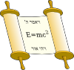

*c*  *a*

or *c* as the subject *b*

**Example**

|  |  |  |
| --- | --- | --- |
| Equation | First Rearrangement | Second Rearrangement |
| *v*  *f*   | *f*  *v*   | ●  *v f* |
| *T*  1  *f* | 1  *T*  *f* | *f*  1  *T* |

**Exercise**

From now on the multiplication sign will not be shown, so

*a*  *bc*

*a*  *b*  *c* will be simply written as

|  |  |  |
| --- | --- | --- |
| Equation | First Rearrangement | Second Rearrangement |
| (Power of lens) *P*  1  *f* | 1  | *f*  |
| *v*  (Magnification of lens) *m*   *u* | *v*  | *u*  |
| *c*  (refractive index) *n*   *v* | *c*  | *v*  |
| *Q*  (current) *I*   *t* |  |  |
| *E*  (electric potential) *V*   *Q* |  |  |
| *E*  (power) *P*   *t* |  |  |
| (power) *P*  *VI* |  |  |
| *I*  (conductance) *G*   *V* |  |  |
| *V*  (resistance) *R*   *I* |  |  |
| (resistance) *R*  1  *G* |  |  |
| (power) *P*  *I* 2 *R* |  |  |
| *V* 2  (power) *P*   *R* |  |  |
| *F*  (stress)    *A* | *F*  | *A*  |
| *x*  (strain)    *l* | *x*  | *l*  |

**Exercise**

Further rearranging practice questions:

|  |  |  |  |
| --- | --- | --- | --- |
| **1.** | a = bc | b=? |  |
| **2.** | a = b/c | b=? | c=? |
| **3.** | a = b – c | c=? |  |
| **4.** | a = b + c | b=? |  |
| **5.** | a = bc + d | c=? |  |
| **6.** | a = b/c – d | c=? |  |
| **7.** | a = bc/d | d=? | b=? |
| **8.** | a = (b + c)/d | c=? |  |
| **9.** | a = b/c + d/e | e=? |  |

**Chapter 6**

**Using Your Calculator**

In A Level Physics you will need to use a scientific calculator. We recommend a ‘natural display’

calculator such as the Casio fx-83ES model, shown here:

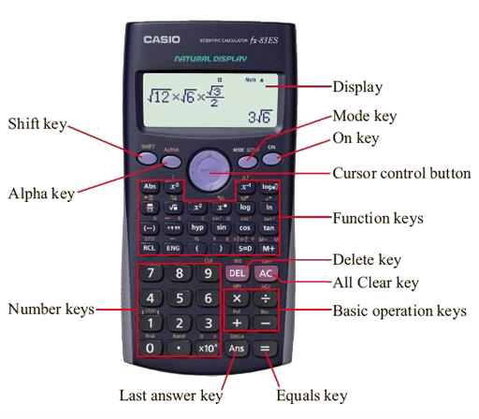

**Exercise**

Using your calculator, evaluate:

30

5 × 3 = ?

What answer did you get? 18 or 2? If you got 18 you were wrong. Nope – there’s nothing wrong

with your calculator we just need to establish exactly how it works.

You need to be able to use your calculator confidently to do the following things:

• Fractions or decimals

• Powers and surds (i.e. square roots)

• Making corrections or reusing a previous result

• Using your calculator for negative numbers

• Using the calculator memory

• Using standard form on your calculator

• Trigonometry on your calculator

• Radians on your calculator

• Logarithms, Natural logarithms and powers of e on your calculator

If you are in any doubt about how to the things above on your calculator you should visit the Open

University website and complete their ‘Using a Scientific Calculator’ module here:

<http://www.open.edu/openlearn/education/mathematics-education/using-scientific-> calculator/content-section-0

**Exercise**

Always give your answer in standard form,

e.g. 7.0 x 10-3 and not as 7.0-3 or 7000 which is how it may be displayed on the calculator.

Your answer should have the same amount of significant figures as the question.

**1.** (7.5 × 103) × 24 =

**2.** (6.2 × 10−5) × (5.0 × 10−3) =

**3.** (1.4 × 105) × (2.0 × 104 ) =

(4.5×103)

**4.** (7.0×104) =

4.3×10−6

**5.** 6.0×103 =

**Exercise**

In each case, find the value of y

**1.** 𝑦 = (7.5 × 103 )2

(1.3×103)× (1.6×10−4)

= (6.6×106)+(3.27×10−3)

−4 2 8

(5.6×10) × (7.8×10 )

(6.6×106 )+ (3.27×10−3)

(4.12×103)+(6.5×102)

**4.** 𝑦 = √

(2.3×104)×(8.1×102)

**Chapter 7**

**Significant Figures**

You can lose a mark if you quote too many significant figures in an answer, it is just as bad as leaving off a unit when answering a question –why lose marks needlessly when you don’t have to?

**The Rules**

1. All non-zero digits are significant. E.g. **6529**0, **5**000, 0.**34** (numbers highlighted bold are significant)

2. In a number without a decimal point, only zeros BETWEEN non-zero digits are significant. E.g. the zeros are significant in **12001** but not in **121**00.

3. In a number with a decimal point, all zeros to the right of the right-most non-zero digit are significant. E.g. **12.100**, **2.010**, **3.01**, 0.0**120**

**Examples**

**39.389** → 5 s.f. (5 significant figures)

**12**0000000000000→ 2 s.f.

**3400.000** → 7 s.f.

**34224**000 → 5 s.f.

**200000.0004** → 10 s.f.

**Exercise**

How many significant figures are the following numbers quoted to?

|  |  |
| --- | --- |
| 1. | 224.4343 |
| 2. | 0.00000000003244654 |
| 3. | 3442.34 |
| 4. | 200000 |
| 5. | 43.0002 |
| 6. | 24540000 |
| 7. | 543325 |
| 8. | 23.5454353 |
| 9. | 4.0000000000 |
| 10. | 4456001 |

For the numbers above that are quoted to more than 3 s.f., convert the number to standard form and quote to 3 s.f.

**Using a Reasonable Number of S.F.**

When answering a question you should write your final answer using the same number of s.f. as those provided in the question. You can sometimes go to just one more.

**Example**

Let’s say we were faced with this question:

*A man runs 110 metres in 13 seconds, calculate his average speed.*

Distance = 110 m

Time = 13 s

Speed = Distance/Time = 110 metres / 13 seconds

= 8.461538461538461538461538461538 ms-1

**This is a ridiculous number of significant figures!**

= 8.46 ms-1 seems acceptable (i.e. given to 3 s.f.) because the figures we were given in the question we given to 2 s.f. We’ve used just one more than was given in our question which is fine.

**Exercise**

How many significant figures would you quote the answers to the following questions to?

**1.** The resultant force on a body of mass 4.0 kg is 20 N. What is the acceleration of the body?

**2.** A particle which is moving in a straight line with a velocity of 15 ms-1 accelerates uniformly for

3.0s, increasing its velocity to 45 ms-1. What distance does it travel whilst accelerating?

**3.** A car moving at 30 ms-1 is brought to rest with a constant retardation of 3.6 ms-2. How far does it travel whilst coming to rest?

**4.** A man of mass 75 kg climbs 300 m in 30 minutes. At what rate is he working?

**5.** What is the maximum speed at which a car can travel along a level road when its engine is developing 24kW and there is a resistance to motion of 800 N?

**Chapter 8**

**Example Numerical Problems**

**A Step by Step Guide on Tackling a Numerical Problem**

Let’s try a typical question from a worksheet given out in class: The question says:

*Gravitational field strength (g) = 9.81 Nkg-1*

*2. A book is picked up from the floor by a librarian and placed onto a shelf 2.5 m high. The book has a mass of 500 g. Calculate:*

*(a) The energy gained by the book.*

***Step 1:*** *Write down the values of everything you are given and put a question mark next to what you are asked to work out:*

**g = 9.81 Nkg-1**

**h = 2.5 m m = 500 g E = ?**

***Step 2:*** *Convert all the values into SI units i.e. time in seconds, distances in metres and so on:*

1 kg = 103 g

So now replace 500 g with 500/103 kg:

**g = 9.81 Nkg-1**

**h = 2.5 m**

**m = 500 g = 0.5 kg**

**E = ?**

***Step 3:*** *Pick an equation that contains the values we know and the quantity we are trying to work out:*

So we want an equation with m, g, h and E in it. This looks like a job for the gravitational potential energy equation:

𝐸 = 𝑚 × g × ℎ

***Step 4:*** *Insert the values into the equation including the units:*

𝐸 = 𝑚 × g × ℎ = 0.5 × 9.81 × 2.5 𝑚

***Step 4:*** *Type it into our calculator to get the answer and quote the answer to a reasonable number of significant figures:*

Answer in the calculator:

𝐸 = 12.2625

E = 12.3 J (3 s.f)

***Step 5:*** *Pause for one moment and think about if our answer is sensible.*

**Chapter 10**

**General Information**

**Useful Web Links**

These are general links which you may find useful for revision and independent study. Do have a look at the A level Physics online videos – they explain things really well!

<https://www.youtube.com/results?search_query=year+12+a+level+physics+online>

<https://www.youtube.com/results?search_query=science+shorts+A+level+physics>

https://www.physicsandmathstutor.com/physics-revision/a-level-ocr-a/ <http://www.s-cool.co.uk/a-level/physics><http://www.physicsclassroom.com/><http://www.school-for-champions.com/physics.htm><http://www.cyberphysics.co.uk/index.html>

**Textbooks and revision guides**

Within the month of term you should order an A Level Physics textbook OCR Specification A. This book is a detailed guide to the course and should be brought to every lesson.

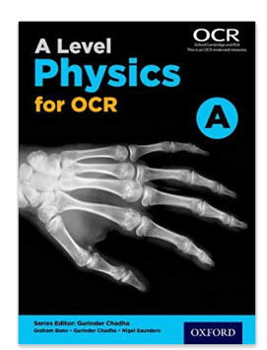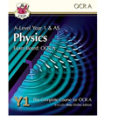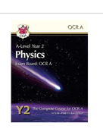

Should you wish to purchase further revision guides and texts books, Amazon is a good website. I would **HIGHLY RECOMMEND** the CGP books above as they really do explain some of the difficult concepts in simple terms and are easier to read and understand.