June 2021 Our Ref: KS / FIN

Dear Sir / Madam

**Bus Passes 2021 / 2022**

Please find enclosed the bus timetable for the new academic year.

Please complete and return the enclosed authorisation form to confirm that you wish to accept the allocated seat and are aware of the terms and conditions of the issue of the bus pass. All forms need to be returned to Mrs K Smith, Assistant Business Manager by the Friday 20th August 2021, together with a minimum deposit of £120.

The new bus passes require a passport size photo and will be distributed during the first week of term. Students will be allowed to travel on buses during that first week without a pass. If by the end of Friday 10th September, your son/daughter has not received a pass, please ensure that they report this to Student Services.

The cost of a Bus Pass for the Academic Year is **£820.** This equates to a cost of £4.34 per day.

We would like to reiterate that the school does not receive any funding for bus passes and does not make any profit from them.

**Please be aware that you are committed to use the bus service for the whole of the Academic Year and should your circumstances change you will be liable for the whole cost of the bus pass.**

**In the event of any future school closure due to COVID-19 then you will only pay for the time the school is open and the buses are in operation.**

Enclosed is a standing order mandate should you wish to make payment for the bus pass using this method. This payment method would be for 10 monthly payments of £70.00. Please return this mandate to the school, together with the authorisation form, in order that we can ensure our records are correct. If you wish to pay by an alternative method you will need to ensure that, after the initial deposit, we receive a further £235 by 30 November 2021, £235 paid by 31 March 2022 and the final amount of £230 (making a total balance of £820) by 30 June 2022.

If you require any further information, please do not hesitate to contact me. My direct telephone number is 01536 359409 or email [ksmith@bishopstopford.com](mailto:ksmith@bishopstopford.com).

Yours sincerely

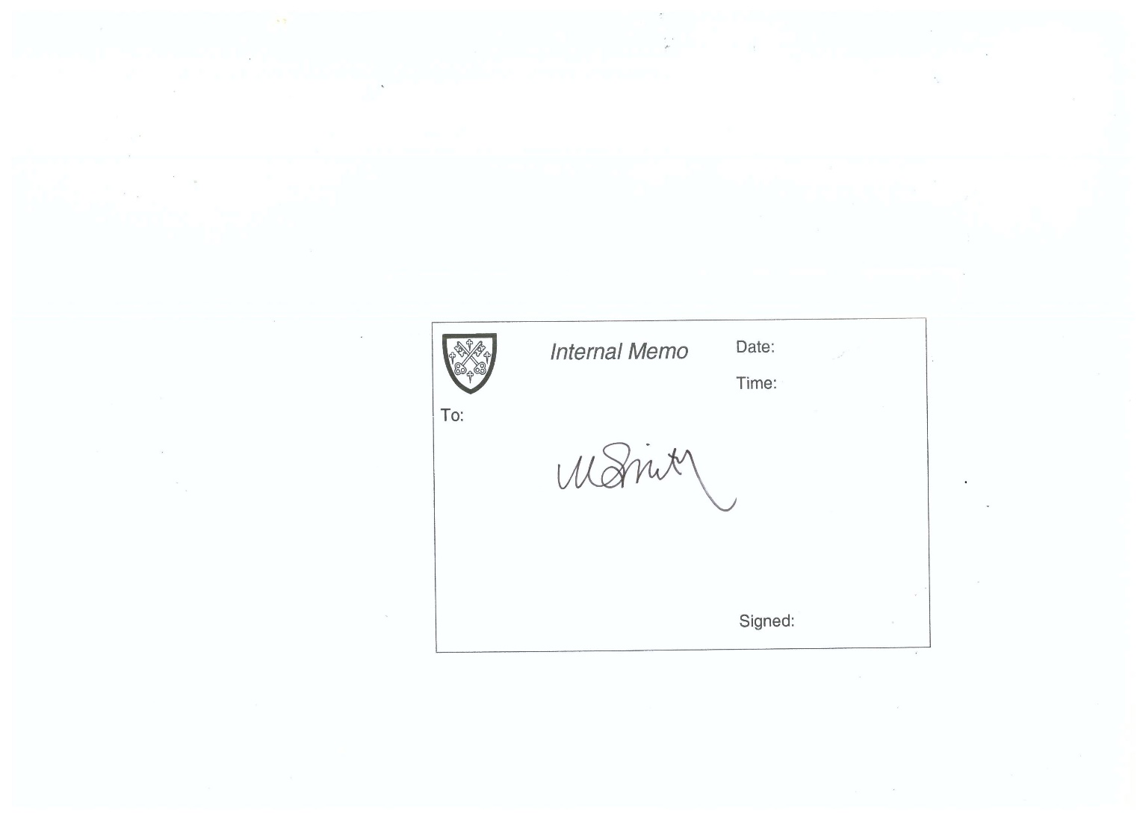

Mrs Kirsty E Smith

Assistant Business Manager