My Favourite Book

Non-fiction

Title:

Explain what this information book is about.

Author:

Interesting facts I

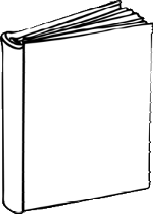

5

learned from this book:

Remember to write facts in your own words!

1.

Page

2.

I rate this book:

Page

3.

Page

4.

If I had to design

a new cover for this book it would look like this:

Why?

Page

Explain why you like

this book so much.

5.

Page

By: ..........................................