### Maths skills

#### 1 Core mathematics

###### Practice questions

1. **a** 1.413 × 103 °C **b** 1.0 × 10−7 m

**c** 1.806 × 1021 atoms

1. **a** 0.000 0055 **b** 290

**c** 11150 **d** 0.001 412

**e** 72

1. **a** 36.9 **b** 260

**c** 0.043 **d** 8 000 000

1. Number of molecules = 0.5 moles × 6.022 × 1023 = 3.011 × 1023 = 3.01 × 1023
2. **a** 4.8 **b** 0.54

**c** 1.01 **d** 2.000

1. **a** 0.0003 m **b** 5 × 109­­ mJ

**c** 1 × 107 kW

#### 2 Balancing chemical equations

###### Practice questions

1. **a** 2C + O2 → 2CO **b** N2 + 3H2 → 2NH3

**c** C2H4 + 3O2 → 2H2O + 2CO2

1. **a** C6H14 + 9O2 → 6CO2 + 7H2O **or** 2C6H14 + 19O2 → 12CO2 + 14H2O

**b** 2NH2CH2COOH +4O2 → 4CO2 + 5H2O + N2

**or** 4NH2CH2COOH +9O2 → 8CO2 + 10H2O + 2N2

1. **a** Mg(OH)2 + 2HNO3 🡪 Mg(NO3)2 + 2H2O

**b** 3Fe(NO3)2 + 2Na3PO4 🡪 Fe3(PO4)2 + 6NaNO3

#### 3 Rearranging equations and calculating concentrations

###### Practice questions

1. **a** *n* = *cv* **b** 
2. **a**  **b** 

**3** 4.0 mol dm−3

**4** 0.025 mol dm−3

**5** 3.6 × 10−3mol

#### 4 Molar calculations

###### Practice questions

1. **a** = 0.02 mol **b** 0.02 mol

**c** 0.02 × 40.3 = 0.806 g

**2** **a** = 0.05 mol **b** = 0.025 mol

**3** **a** = 5.93 mol **b** 5.93 mol

#### 5 Percentage yields and percentage errors

###### Practice questions

1. 3.19/4.75 × 100 = 67.2%

**2** 6.25/12.00 × 100 = 52.1%

**3** **a** 0.5/21 × 100 = 2.38% **b** 0.5/43 × 100 = 1.16%

**4** **a** 0.5 × (2/12) × 100 = 8.33% **b** 0.5 × (2/37.6) × 100 = 2.66%

#### 6 Graphs and tangents

***Practice questions***

1. 
2. **a**

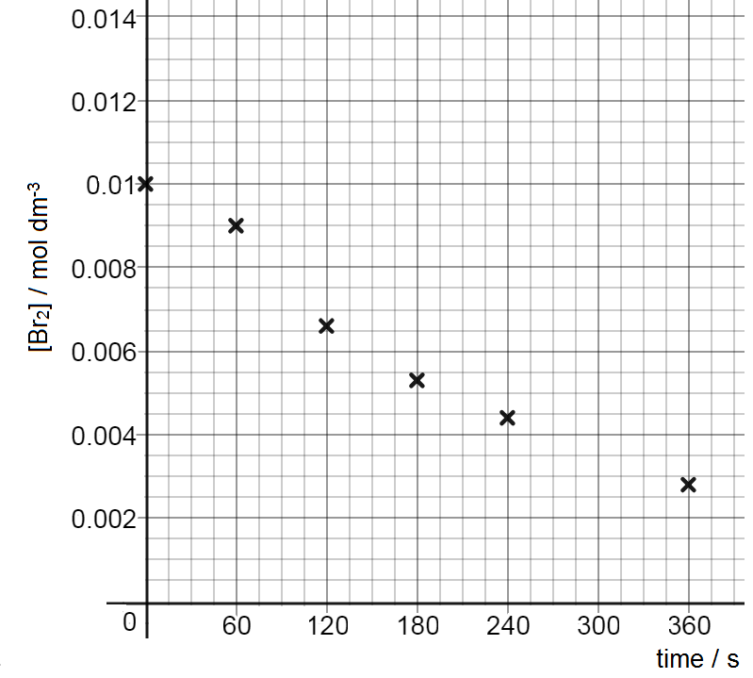

**b** Half-life is approximately 180 seconds **c** The reaction is first order