Hello!

We are really excited that you have opted to take Language and Literature A' Level. In order to get prepared, we thought we would let you know what texts we are going to study over the year:

(Needed in September 2021)

ISBN: 978-0-141-18997-0

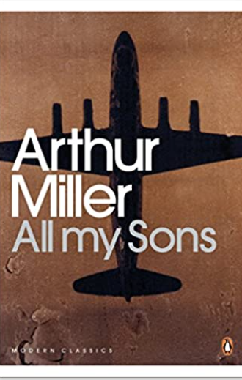

(Needed in January 2022) ISBN: 978-1-85326-018-6

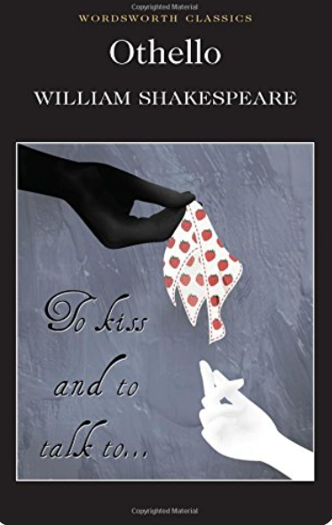

 (Needed in September 2021) ISBN: 978-1-85326-041-4

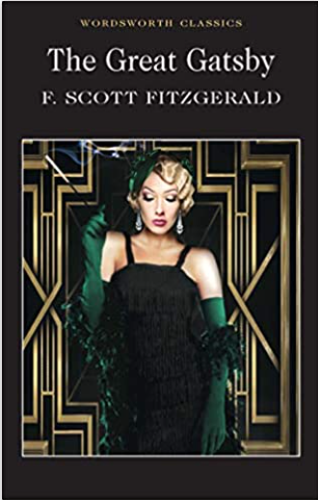

(Needed in June 2022)

ISBN 10: [1845291654](https://mcas-proxyweb.mcas.ms/certificate-checker?login=false&originalUrl=https%3A%2F%2Fwww.abebooks.co.uk.mcas.ms%2Fproducts%2Fisbn%2F9781845291655%3Fcm_sp%3Dbdp-_-ISBN10-_-PLP) /

ISBN 13: [9781845291655](https://mcas-proxyweb.mcas.ms/certificate-checker?login=false&originalUrl=https%3A%2F%2Fwww.abebooks.co.uk.mcas.ms%2Fproducts%2Fisbn%2F9781845291655%3Fcm_sp%3Dbdp-_-ISBN13-_-PLP)

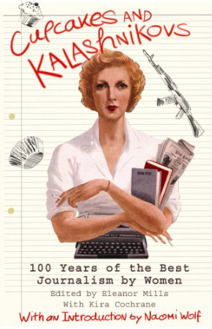

(Needed after Easter 2022) ISBN: 978-1-4088-2485-6



Please note that buying second-hand books is fine, as long as there are not too many annotations in the first three texts as they are the exam texts, as we will be annotating them in class. If you have a different publication of the text that is fine too but the first three are the ones that will be used as clean texts in the exams so it would be better to familiarise yourself with these editions.

Please email me if you need any help with any of the preparation for A' Level Language and Literature.

I'm looking forward to welcoming you as a sixth former next September.  Have a lovely summer.

Mrs Pointer

[jpointer@bishopstopford.com](mailto:jpointer@bishopstopford.com)