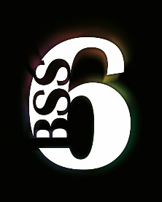

**SIXTH FORM DRESS CODE**

At Bishop Stopford School, staff and sixth form students are required to dress in a manner which reflects the ethos and high expectations of the school, providing good role models to students in the lower school. The Sixth Form Dress Code parallels that for staff, ensuring there is consistency in the messages given.

School issued lanyards must be worn at all times by staff and sixth form students.

**General Principles**

* Clothing choices are personal, and making judgments about suitability can be subjective – even within strict dress codes. The final decision on whether or not clothing is appropriate to the school environment lies with the Sixth Form Leadership Team.
* If dress is deemed inappropriate, the Sixth Form Leadership team will discuss concerns with the student and the changes required. Any student who subsequently does not comply with the dress code will be sent home to change.

**Acceptable Dress**

* Clothing must be professional dress.
* Male clothing must include a shirt and tie.
* Female clothing includes trousers (full or ¾ length, but no shorter). Trousers must be formal and tailored. Skirts and dresses should not be too short (within 10cm of the knee).
* Formal shoes or boots.
* Discreet jewellery.

**The following illustrates what is not appropriate (this is not an exhaustive list):**

* Denim.
* Revealing or excessively tight clothing.
* Shorts.
* Combat or cargo trousers.
* Leggings.
* Inappropriate footwear e.g. flip flops, canvas shoes or trainers.
* ’Strappy’ (i.e. narrow shoulder straps), low cut or strapless tops.
* Extreme hairstyles or colours.
* Visible tattoos.

July 2018