My Favourite Book

fiction

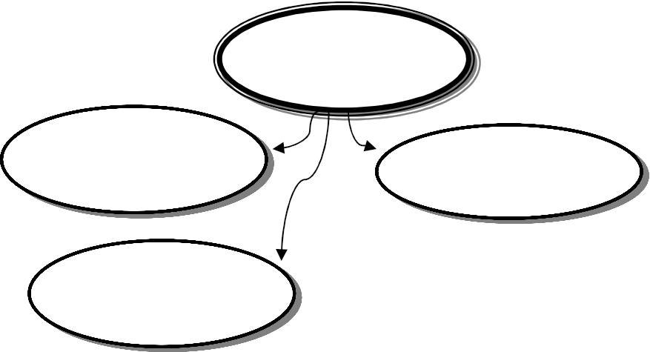

Title: Author:

Why?

Explain why you like this book so much.

If I had to design a new cover for this book it would look like this:

Summarise what happens in this story.

GENRE

realistic fiction historical fiction science fiction fantasy

horror other

Name and describe the main character.

setting

This story mostly takes place



Draw the main setting.

I rate this book:

By: ..........................................